AL 102
Aluminum Metal Powder, Plasma Spray Grade

Catalog #

Formula | Al
Purity | 99.8% min metals basis
Particle size | -100 + 325 mesh

Chemistry

Elements | Specification | Typical Results
Aluminum | 99.8% min | >99.8
Iron | <0.10 | 0.09
Silicon | <0.10 | 0.03

1–5-micron APS

+100 mesh | -100+325 mesh | -325 mesh
1.4 | 92.8 | 4.6

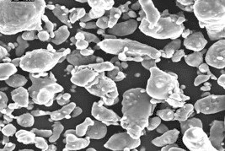

A silvery white, light, durable and functional metal, making it one of the most critical engineering and manufacturing materials. Aluminum is one of the lightest metals to exist. It is particularly known for its strength, flexibility, and corrosion resistance. Since it cannot become magnetized, it makes for a great electricity conductor, and readily makes alloys with almost any metal. It can be found in a diverse range of applications, from planes, trains and automobiles to telephones and everyday objects, many of which would simply not exist without aluminum.

